Objectives

1. Research information about software for a specific operating system (OS) environment. You will be assigned one of the operating systems form the list of: Windows, Mac OS, Linux. You will also be provided with a list of topics to investigate.

2. Organize your rough research information into a list of topics, sub-topics and facts. This process will involve identifying sub-topics, rearranging your rough research notes, and selecting (or highlighting) interesting facts.

3. Report a summary of your research in the form of a “concept map”. Use the PowerPoint template provided as a starting point. The concept map should only include the best and most interesting information from your organized research notes.

Your assigned operating system is:

· Windows

· Mac OS

· Linux

· iOS

· Android

A concept map can be created using the “Smart Ideas” application or PowerPoint or other applications.

Level 1 – Rough Research

Research information about the software for your assigned operating system (OS) environment.

· Guide your research according to the suggested topic list below

· Feel free to copy-and-paste as long as you keep track of your bibliographic references.

· Do not be too picky or concerned about formatting as you will organize this information later in step 2

· Select things that look interesting and don’t forget to include graphics images as well

· Upload your rough research notes to your repository when you are done.

**Topic A – Productivity, Entertainment & Other Software Applications**

Productivity:

* [Microsoft Entourage](https://en.wikipedia.org/wiki/Microsoft_Entourage)
* [Microsoft FrontPage](https://en.wikipedia.org/wiki/Microsoft_FrontPage)
* [Microsoft InfoPath](https://en.wikipedia.org/wiki/Microsoft_InfoPath)
* [Microsoft MapPoint](https://en.wikipedia.org/wiki/Microsoft_MapPoint)
* [Microsoft Money](https://en.wikipedia.org/wiki/Microsoft_Money)
* [Microsoft Office shared tools](https://en.wikipedia.org/wiki/Microsoft_Office_shared_tools)
* [Microsoft Office Picture Manager](https://en.wikipedia.org/wiki/Microsoft_Office_Picture_Manager)
* [Office Assistant](https://en.wikipedia.org/wiki/Office_Assistant)
* [Microsoft Response Point](https://en.wikipedia.org/wiki/Microsoft_Response_Point)
* [Microsoft SharePoint Workspace](https://en.wikipedia.org/wiki/Microsoft_SharePoint_Workspace)
* [Microsoft Schedule+](https://en.wikipedia.org/wiki/Microsoft_Schedule_Plus)
* [Microsoft Vizact](https://en.wikipedia.org/wiki/Microsoft_Vizact)
* [Microsoft Works](https://en.wikipedia.org/wiki/Microsoft_Works)
* [Microsoft Dynamics](https://en.wikipedia.org/wiki/Microsoft_Dynamics)
* [Wunderlist](https://en.wikipedia.org/wiki/Wunderlist)

Entertainment:

Video games

* [Xbox Game Studios](https://en.wikipedia.org/wiki/Xbox_Game_Studios)
* [Age of Empires](https://en.wikipedia.org/wiki/Age_of_Empires_(series)) series
* [Banjo-Kazooie](https://en.wikipedia.org/wiki/Banjo-Kazooie_(series)) series
* [Battletoads](https://en.wikipedia.org/wiki/Battletoads) series
* [Crackdown](https://en.wikipedia.org/wiki/Crackdown) series
* [Fable](https://en.wikipedia.org/wiki/Fable_(video_game_series)) series
* [Forza](https://en.wikipedia.org/wiki/Forza_(series)) series
* [Gears of War](https://en.wikipedia.org/wiki/Gears_of_War) series
* [Halo](https://en.wikipedia.org/wiki/Halo_(series)) series
* [Killer Instinct](https://en.wikipedia.org/wiki/Killer_Instinct) series
* [Microsoft Flight Simulator](https://en.wikipedia.org/wiki/Microsoft_Flight_Simulator)
* [Minecraft](https://en.wikipedia.org/wiki/Minecraft)
* [Ori](https://en.wikipedia.org/wiki/Ori_and_the_Blind_Forest) series
* [Perfect Dark](https://en.wikipedia.org/wiki/Perfect_Dark_(series)) series
* [Solitaire](https://en.wikipedia.org/wiki/Microsoft_Solitaire_Collection)
* [State of Decay](https://en.wikipedia.org/wiki/State_of_Decay_(video_game)) series
* [Zoo Tycoon](https://en.wikipedia.org/wiki/Zoo_Tycoon) series

3D

* [Bing Maps for Enterprise](https://en.wikipedia.org/wiki/Bing_Maps_Platform)
* [Direct3D](https://en.wikipedia.org/wiki/Direct3D)
* [Havok](https://en.wikipedia.org/wiki/Havok_(software))
* [HoloStudio](https://en.wikipedia.org/wiki/Microsoft_HoloLens#Applications)
* [Kinect for Windows SDK](https://en.wikipedia.org/wiki/Kinect#Kinect_for_Windows)
* [Microsoft Softimage](https://en.wikipedia.org/wiki/Softimage_(company)#1994_-_Microsoft_Softimage)
* [Paint 3D](https://en.wikipedia.org/wiki/Paint_3D)
* [Simplygon](https://en.wikipedia.org/wiki/Simplygon)
* [trueSpace](https://en.wikipedia.org/wiki/TrueSpace)
* [View 3D](https://en.wikipedia.org/wiki/View_3D)

Software Applications:

Software development

* [BASICA](https://en.wikipedia.org/wiki/BASICA)
* Citus Data
* [CLR Profiler](https://en.wikipedia.org/wiki/CLR_Profiler)
* [GitHub](https://en.wikipedia.org/wiki/GitHub)
* [GW-BASIC](https://en.wikipedia.org/wiki/GW-BASIC)
* [IronRuby](https://en.wikipedia.org/wiki/IronRuby)
* [IronPython](https://en.wikipedia.org/wiki/IronPython)
* [JScript](https://en.wikipedia.org/wiki/JScript)
* [Microsoft Liquid Motion](https://en.wikipedia.org/wiki/Microsoft_Liquid_Motion)
* [Microsoft Macro Assembler](https://en.wikipedia.org/wiki/Microsoft_Macro_Assembler)
* [Microsoft Small Basic](https://en.wikipedia.org/wiki/Microsoft_Small_Basic)
* [Microsoft Visual SourceSafe](https://en.wikipedia.org/wiki/Microsoft_Visual_SourceSafe)
* [Microsoft XNA](https://en.wikipedia.org/wiki/Microsoft_XNA)
* [Microsoft WebMatrix](https://en.wikipedia.org/wiki/Microsoft_WebMatrix)
* [MSX BASIC](https://en.wikipedia.org/wiki/MSX_BASIC)
* [NuGet](https://en.wikipedia.org/wiki/NuGet)
* [QBasic](https://en.wikipedia.org/wiki/QBasic) and [QuickBASIC](https://en.wikipedia.org/wiki/QuickBASIC)
* [Team Foundation Server](https://en.wikipedia.org/wiki/Team_Foundation_Server)
* [VBScript](https://en.wikipedia.org/wiki/VBScript)
* [Visual Studio](https://en.wikipedia.org/wiki/Visual_Studio)
* [Microsoft Visual Studio Express](https://en.wikipedia.org/wiki/Microsoft_Visual_Studio_Express)
* [Visual Basic](https://en.wikipedia.org/wiki/Visual_Basic)
* [Visual Basic .NET](https://en.wikipedia.org/wiki/Visual_Basic_.NET)
* [Visual Basic for Applications](https://en.wikipedia.org/wiki/Visual_Basic_for_Applications)
* [Visual C++](https://en.wikipedia.org/wiki/Visual_C%2B%2B)
* [C++/CLI](https://en.wikipedia.org/wiki/C%2B%2B/CLI)
* [Managed Extensions for C++](https://en.wikipedia.org/wiki/Managed_Extensions_for_C%2B%2B)
* [Visual C#](https://en.wikipedia.org/wiki/Visual_C_Sharp)
* [Visual FoxPro](https://en.wikipedia.org/wiki/Visual_FoxPro)
* [Visual J++](https://en.wikipedia.org/wiki/Visual_J%2B%2B)
* [Visual J#](https://en.wikipedia.org/wiki/Visual_J_Sharp)
* [Visual Studio Code](https://en.wikipedia.org/wiki/Visual_Studio_Code)
* [Visual Studio Lab Management](https://en.wikipedia.org/wiki/Visual_Studio_Lab_Management)
* [Visual Studio Team Services](https://en.wikipedia.org/wiki/Microsoft_Visual_Studio#Team_Services)
* [Visual Studio Tools for Office](https://en.wikipedia.org/wiki/Visual_Studio_Tools_for_Office)
* [Visual Studio Tools for Applications](https://en.wikipedia.org/wiki/Visual_Studio_Tools_for_Applications)
* [VSTS Profiler](https://en.wikipedia.org/wiki/VSTS_Profiler)
* [Windows API](https://en.wikipedia.org/wiki/Windows_API)
* [Windows SDK](https://en.wikipedia.org/wiki/Windows_SDK)
* [WordBASIC](https://en.wikipedia.org/wiki/WordBASIC)
* [Xbox Development Kit](https://en.wikipedia.org/wiki/Xbox_Development_Kit)

[Office 365](https://en.wikipedia.org/wiki/Office_365) Applications

* [Microsoft Access](https://en.wikipedia.org/wiki/Microsoft_Access)
* [Microsoft Excel](https://en.wikipedia.org/wiki/Microsoft_Excel)
* [Microsoft OneNote](https://en.wikipedia.org/wiki/Microsoft_OneNote)
* [Microsoft Outlook](https://en.wikipedia.org/wiki/Microsoft_Outlook)
* [Microsoft Power BI](https://en.wikipedia.org/wiki/Microsoft_Power_BI)
* [Microsoft PowerPoint](https://en.wikipedia.org/wiki/Microsoft_PowerPoint)
* [Microsoft Project](https://en.wikipedia.org/wiki/Microsoft_Project)
* [Microsoft Publisher](https://en.wikipedia.org/wiki/Microsoft_Publisher)
* [Microsoft Sway](https://en.wikipedia.org/wiki/Microsoft_Sway)
* [Microsoft Teams](https://en.wikipedia.org/wiki/Microsoft_Teams)
* [Microsoft Visio](https://en.wikipedia.org/wiki/Microsoft_Visio)
* [Microsoft Word](https://en.wikipedia.org/wiki/Microsoft_Word)
* [Outlook Web App](https://en.wikipedia.org/wiki/Outlook_Web_App)
* [Skype for Business](https://en.wikipedia.org/wiki/Skype_for_Business)

Windows components

* [ClickOnce](https://en.wikipedia.org/wiki/ClickOnce)
* [DirectX](https://en.wikipedia.org/wiki/DirectX)
* [Disk Cleanup](https://en.wikipedia.org/wiki/Disk_Cleanup)
* [Ease of Access](https://en.wikipedia.org/wiki/Ease_of_Access)
* [File Explorer](https://en.wikipedia.org/wiki/File_Explorer)
* [Internet Explorer](https://en.wikipedia.org/wiki/Internet_Explorer)
* [Internet Information Services](https://en.wikipedia.org/wiki/Internet_Information_Services)
* [Hyper-V](https://en.wikipedia.org/wiki/Hyper-V)
* [Microsoft Agent](https://en.wikipedia.org/wiki/Microsoft_Agent)
* [Microsoft Calculator](https://en.wikipedia.org/wiki/Microsoft_Calculator)
* [Microsoft Command Prompt](https://en.wikipedia.org/wiki/Microsoft_Command_Prompt)
* [Microsoft Cortana](https://en.wikipedia.org/wiki/Microsoft_Cortana)
* [Microsoft Edge](https://en.wikipedia.org/wiki/Microsoft_Edge)
* [Microsoft Magnifier](https://en.wikipedia.org/wiki/Microsoft_Magnifier)
* [Microsoft Narrator](https://en.wikipedia.org/wiki/Microsoft_Narrator)
* [Microsoft Notepad](https://en.wikipedia.org/wiki/Microsoft_Notepad)
* [Microsoft Paint](https://en.wikipedia.org/wiki/Microsoft_Paint)
* [Microsoft Speech API](https://en.wikipedia.org/wiki/Microsoft_Speech_API)
* [Microsoft Store](https://en.wikipedia.org/wiki/Microsoft_Store)
* [Microsoft Wordpad](https://en.wikipedia.org/wiki/Microsoft_Wordpad)
* [On-screen keyboard](https://en.wikipedia.org/wiki/On-screen_keyboard)
* [Registry editor](https://en.wikipedia.org/wiki/Registry_editor)
* [Windows Chat](https://en.wikipedia.org/wiki/Windows_Chat)
* [Windows Defender](https://en.wikipedia.org/wiki/Windows_Defender)
* [Windows Disk Defragmenter](https://en.wikipedia.org/wiki/Windows_Disk_Defragmenter)
* [Windows Easy Transfer](https://en.wikipedia.org/wiki/Windows_Easy_Transfer)
* [Windows Installer](https://en.wikipedia.org/wiki/Windows_Installer)
* [Windows Media Player](https://en.wikipedia.org/wiki/Windows_Media_Player)
* [Windows PowerShell](https://en.wikipedia.org/wiki/Windows_PowerShell)
* [Windows Services for UNIX](https://en.wikipedia.org/wiki/Windows_Services_for_UNIX)
* [Windows Speech Recognition](https://en.wikipedia.org/wiki/Windows_Speech_Recognition)
* [Windows To Go](https://en.wikipedia.org/wiki/Windows_To_Go)

Some graphics: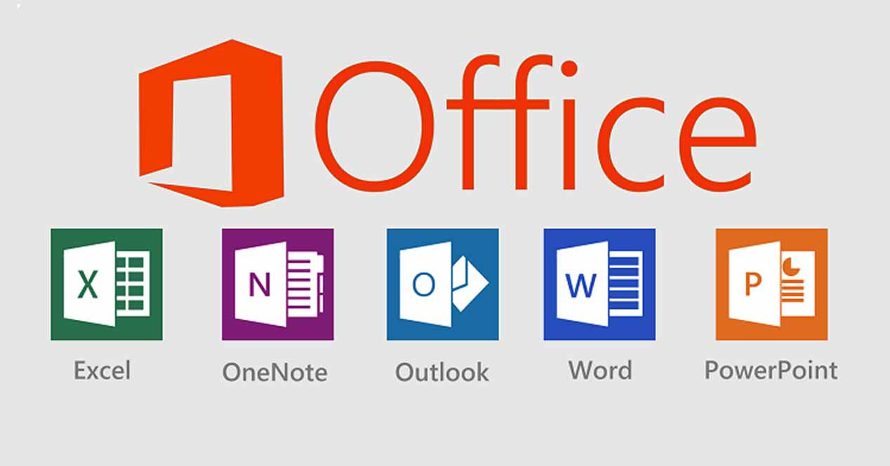

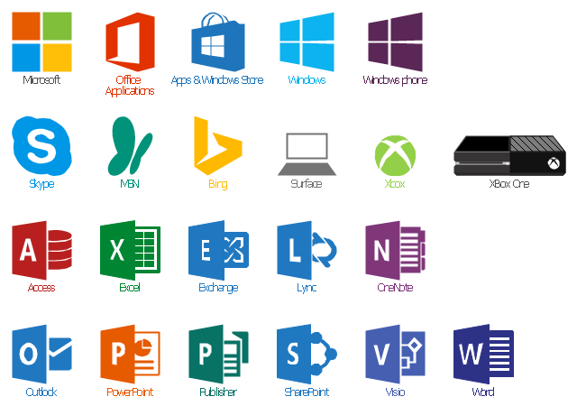

**Topic B – User Interface (Window Management & Input Devices)**

Windows Controls

Windows controls are user interface elements that are used in conjunction with another window (typically a client window or dialog box) to enable the user to interact with an application. Many of the elements that make up the UI of a traditional Windows-based application are Windows controls, including items such as menus, scroll bars, buttons, list boxes, tree views, and so on. Windows controls are supported by all versions of Windows. However, because the run-time components that support the controls have evolved over time, some controls and features introduced in later versions are not supported in earlier versions. Applications need to detect the versions and use only the available features.

You should use Windows controls if you want to create a traditional UI for an unmanaged Windows-based application that runs on a wide range of Windows versions.

Visual Styles

Visual Styles are specifications for the appearance of controls. For example, a Visual Style can define the overall appearance of controls, and enable software developers to configure the visual interface of those controls to coordinate with an application's appearance. Additionally, Visual Styles provide a mechanism for all Windows-based applications to standardize an application's appearance.

Visual styles are supported on Windows XP and later, and they only affect the appearance of the standard Windows controls and the Microsoft Win32 common controls.

You should use Visual Styles if you need to change the appearance of the standard Windows controls and common controls to match the look of your application UI.

Windows Ribbon Framework

The Windows Ribbon framework is a rich command presentation system for Windows-based applications. It consists of a ribbon command bar that exposes the major features of an application through a series of tabs at the top of an application window, and a context menu system. The Windows Ribbon framework is supported on the following Windows versions:

* Windows Vista with Service Pack 2 (SP2) and Platform Update for Windows Vista
* Windows 7 and later
* Windows Server 2008 R2
* Windows Server 2008 with Service Pack 2 (SP2) and Platform Update for Windows Server 2008

You should use Windows Ribbon framework if you want to implement a command UI that is an alternative to the layered menus, toolbars, and task panes of traditional Windows applications.

The Windows Ribbon framework is intended for developers who are proficient in COM programming.

Windows Animation Manager

The Windows Animation Manager supports the animation of UI elements by providing a powerful animation engine and a standardized programmatic interface. The platform simplifies the development and maintenance of UI animation sequences and enables developers to implement UI animations that are consistent and intuitive. Windows Animation can be used with any graphics platform including Direct2D, Microsoft Direct3D, or Windows GDI+. The Windows animation framework is supported on Windows Vista with Platform Update for Windows VistaWindows Vista with SP2 and Platform Update for Windows Vista, and Windows 7 and later.

You should use Windows Animation Manager if you want to add animation sequences to the UI of an unmanaged Windows-based application.

Desktop Window Manager

Desktop Window Manager (DWM) is a Windows runtime component that supports desktop composition, a feature introduced in Windows Vista. Through desktop composition, DWM enables visual effects in the UI, such as glass window frames, 3D window transition animations, Windows Flip and Windows Flip3D, and high resolution support.

DWM exposes an API for controlling many of the visual effects associated with desktop composition. For example, an application can display thumbnails, apply a translucent and blurred effect to the client area of top-level windows, control the transparency and transition effects used in the non-client region of windows, and so on. DWM is supported on Windows Vista and Windows Server 2008.

You should use DWM if your application needs to access and control the visual effects associated with desktop composition.

Windows Automation API

The Windows Automation API helps developers create applications that are accessible to the widest possible audience, including people with vision, hearing, or motion disabilities. The API works by exposing information about the elements that make up an application user interface. Assistive technology applications such as screen readers can use the information to present the UI in a way that can be used by people with disabilities. The Windows Automation API consists of two separate API frameworks, Microsoft Active Accessibility and Microsoft UI Automation. Microsoft Active Accessibility is a legacy API that was introduced in Windows 95 as a platform add-in. UI Automation is the successor to Microsoft Active Accessibility, and is a Windows implementation of the UI Automation specification.

Full support for Microsoft Active Accessibility is built into Windows XP and Windows Server 2003. Microsoft Active Accessibility is also supported on Windows NT 4.0 with Service Pack 6 (SP6) and later, and Windows 98. UI Automation is supported on the following operating systems: Windows XP, Windows Server 2003, Windows Server 2003 R2, Windows Vista, Windows 7, Windows Server 2008, and Windows Server 2008 R2. If your application contains custom controls or other custom UI features, you should use the Windows Automation API to ensure that the custom controls and features are fully accessible. In general, developers need a moderate level of understanding about COM objects and interfaces, Unicode, and Windows API programming.

Speech API

The Microsoft Speech API (SAPI) provides a high-level interface between an application and speech engines. SAPI implements all the low-level details needed to control and manage the real-time operations of various speech engines. The two basic types of SAPI engines are text-to-speech (TTS) systems and speech recognizers. TTS systems synthesize text strings and files into spoken audio using synthetic voices. Speech recognizers convert human spoken audio into readable text strings and files. You should use SAPI if you want to implement a UI that enables the user to interact with your application through TTS and speech recognition in addition to the standard input devices such as the keyboard, mouse, and display.

Magnification API

The magnification API (MAPI) is used to magnify portions of the screen, and to apply color effects and other transforms. This API is primarily intended for assistive-technology applications that enlarge parts of the screen to make them easier to see. MAPI is supported on Windows Vista, Windows 7, Windows Server 2008, and Windows Server 2008 R2. It is intended for developers who are familiar with graphics programming concepts.

Resource Compiler

The Microsoft Windows Resource Compiler is an application development tool used to add UI and other resources to a Windows-based application. A resource is any non-executable data used by an application, and includes such things as dialog boxes, menus, strings, cursors, icons, bitmaps, and so on. The resource compiler is included in Microsoft Visual Studio and the Windows SDK.

User Interface Technologies for Managed Applications

This section describes the Microsoft technologies for developing UIs for managed Windows applications that run in the context of the .NET Framework.

Windows Forms

Windows Forms is a graphical application programming interface for creating managed Windows applications that are based on the .NET Framework. In Windows Forms, a form is a visual surface on which you display information to the user, and through which you receive input from the user.

You build Windows Forms applications by adding controls to forms and developing responses to user actions, such as mouse clicks or key presses. A control is a discrete UI element that displays data or accepts data input. Windows Forms contains a variety of controls that you can add to forms: controls that display text boxes, buttons, drop-down boxes, radio buttons, and even Web pages. Windows Forms also supports creating custom controls.

Windows Presentation Foundation

Windows Presentation Foundation (WPF) is the successor to [Windows Forms](https://go.microsoft.com/fwlink/p/?linkid=191778). WPF is a presentation system for building and rendering user interfaces in Windows-based client applications and browser-hosted applications. The core of WPF is a resolution-independent and vector-based rendering engine that is built to take advantage of modern graphics hardware. WPF extends the core with a comprehensive set of application-development features that include Extensible Application Markup Language (XAML), controls, data binding, layout, 2D and 3D graphics, animation, styles, templates, documents, media, text, and typography. WPF is included in the .NET Framework, so you can build applications that incorporate other elements of the .NET Framework class library. WPF is supported on Windows Vista, Windows 7, Windows Server 2008, Windows Server 2008 R2, and is also available for Windows XP with Service Pack 2 (SP2), and Windows Server 2003.

Silverlight

Microsoft Silverlight is a powerful development platform for creating rich media applications and business applications for the Web, desktop, and mobile devices. Based on the .NET Framework, the free Silverlight plug-in works across multiple browsers, devices, and operating systems to bring new interactivity to the Web. With extensive layout and styling options, powerful communication protocols, robust data access, and support for user interaction and high-definition media, Silverlight helps create fast, smooth, and visually rich customer experiences. Silverlight applications can be developed quickly with the Microsoft Web Platform, Visual Studio, and Expression Studio.

Expression Blend 3 + SketchFlow

Expression Blend 3 + SketchFlow is a visual tool for designing, prototyping, and creating sophisticated user interfaces for WPF and Silverlight desktop and web applications. You build an application by drawing shapes, drawing controls such as buttons and list boxes, making the pieces of your application respond to mouse clicks and other user input, and styling everything to look uniquely your own.

UI Automation for Managed Applications

UI Automation is an accessibility framework for Windows, available on all operating systems that support WPF. UI Automation provides programmatic access to most UI elements on the desktop, enabling assistive technology products such as screen readers to provide information about the UI to end users and to manipulate the UI by means other than standard input. UI Automation also allows automated test scripts to interact with the UI.

Some graphics:

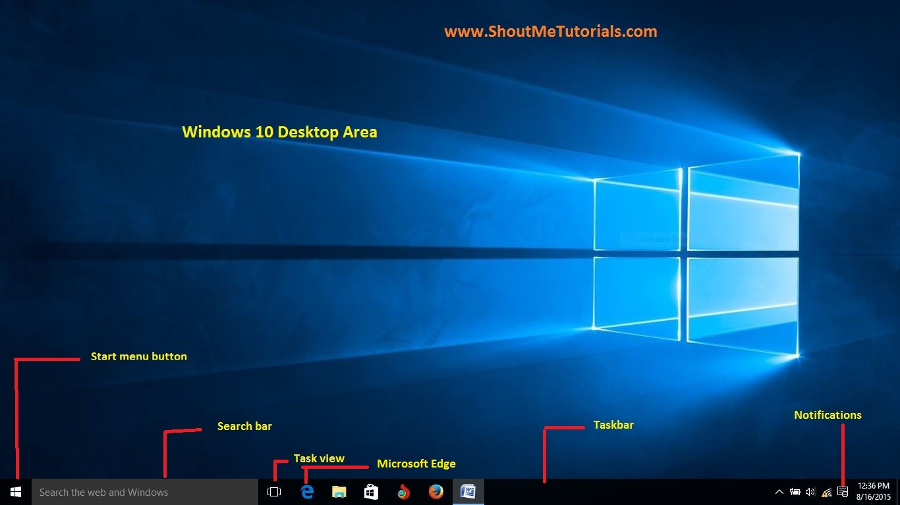

**Topic C – Memory Allocation, Management,& Devices**

The following is a brief comparison of the various memory allocation methods:

* [CoTaskMemAlloc](https://msdn.microsoft.com/en-us/library/ms692727(v=VS.85).aspx)
* [GlobalAlloc](https://docs.microsoft.com/en-us/windows/desktop/api/WinBase/nf-winbase-globalalloc)
* [HeapAlloc](https://docs.microsoft.com/en-us/windows/desktop/api/HeapApi/nf-heapapi-heapalloc)
* [LocalAlloc](https://docs.microsoft.com/en-us/windows/desktop/api/WinBase/nf-winbase-localalloc)
* malloc
* new
* [VirtualAlloc](https://msdn.microsoft.com/en-us/library/Aa366887(v=VS.85).aspx)

Although the [GlobalAlloc](https://docs.microsoft.com/en-us/windows/desktop/api/WinBase/nf-winbase-globalalloc), [LocalAlloc](https://docs.microsoft.com/en-us/windows/desktop/api/WinBase/nf-winbase-localalloc), and [HeapAlloc](https://docs.microsoft.com/en-us/windows/desktop/api/HeapApi/nf-heapapi-heapalloc) functions ultimately allocate memory from the same heap, each provides a slightly different set of functionality. For example, HeapAlloc can be instructed to raise an exception if memory could not be allocated, a capability not available with LocalAlloc. LocalAlloc supports allocation of handles which permit the underlying memory to be moved by a reallocation without changing the handle value, a capability not available with HeapAlloc. Starting with 32-bit Windows, [GlobalAlloc](https://docs.microsoft.com/en-us/windows/desktop/api/WinBase/nf-winbase-globalalloc) and [LocalAlloc](https://docs.microsoft.com/en-us/windows/desktop/api/WinBase/nf-winbase-localalloc) are implemented as wrapper functions that call [HeapAlloc](https://docs.microsoft.com/en-us/windows/desktop/api/HeapApi/nf-heapapi-heapalloc) using a handle to the process's default heap. Therefore, GlobalAlloc and LocalAlloc have greater overhead than HeapAlloc. Because the different heap allocators provide distinctive functionality by using different mechanisms, you must free memory with the correct function. For example, memory allocated with [HeapAlloc](https://docs.microsoft.com/en-us/windows/desktop/api/HeapApi/nf-heapapi-heapalloc) must be freed with [HeapFree](https://docs.microsoft.com/en-us/windows/desktop/api/HeapApi/nf-heapapi-heapfree) and not [LocalFree](https://docs.microsoft.com/en-us/windows/desktop/api/WinBase/nf-winbase-localfree) or [GlobalFree](https://docs.microsoft.com/en-us/windows/desktop/api/WinBase/nf-winbase-globalfree). Memory allocated with [GlobalAlloc](https://docs.microsoft.com/en-us/windows/desktop/api/WinBase/nf-winbase-globalalloc) or [LocalAlloc](https://docs.microsoft.com/en-us/windows/desktop/api/WinBase/nf-winbase-localalloc) must be queried, validated, and released with the corresponding global or local function. The [VirtualAlloc](https://msdn.microsoft.com/en-us/library/Aa366887(v=VS.85).aspx) function allows you to specify additional options for memory allocation. However, its allocations use a page granularity, so using VirtualAlloc can result in higher memory usage. The malloc function has the disadvantage of being run-time dependent. The new operator has the disadvantage of being compiler dependent and language dependent. The [CoTaskMemAlloc](https://msdn.microsoft.com/en-us/library/ms692727(v=VS.85).aspx) function has the advantage of working well in either C, C++, or Visual Basic. It is also the only way to share memory in a COM-based application, since MIDL uses CoTaskMemAlloc and [CoTaskMemFree](https://msdn.microsoft.com/en-us/library/ms680722(v=VS.85).aspx) to marshal memory.

Some graphics:

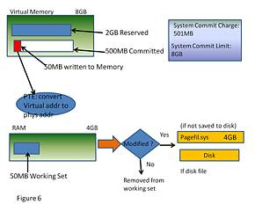

**Topic D – Process / Task Scheduling and Management (System Startup)**

The Task Scheduler enables you to automatically perform routine tasks on a chosen computer. The Task Scheduler does this by monitoring whatever criteria you choose to initiate the tasks (referred to as triggers) and then executing the tasks when the criteria is met.

The Task Scheduler can be used to execute tasks such as starting an application, sending an email message, or showing a message box. Tasks can be scheduled to execute:

* When a specific system event occurs.
* At a specific time.
* At a specific time on a daily schedule.
* At a specific time on a weekly schedule.
* At a specific time on a monthly schedule.
* At a specific time on a monthly day-of-week schedule.
* When the computer enters an idle state.
* When the task is registered.
* When the system is booted.
* When a user logs on.
* When a Terminal Server session changes state.

Developer audience

The Task Scheduler provides APIs for the following developers:

* Task Scheduler 1.0: Interfaces are provided for C++ development.
* Task Scheduler 2.0: Interfaces and objects are provided for C++ and scripting development respectively.

Run-time requirements

The Task Scheduler requires the following operating systems.

* Task Scheduler 1.0: Client requires Windows Vista, or Windows XP. Server requires Windows Server 2008 or Windows Server 2003.
* Task Scheduler 2.0: Client requires Windows Vista. Server requires Windows Server 2008.

Some graphics: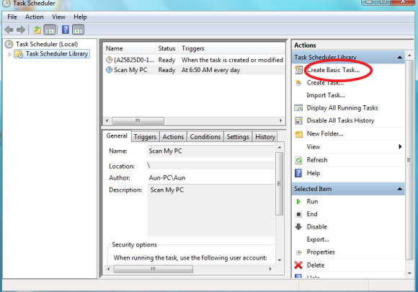

**Topic E – Software Security, Updates & System Tools**

Windows Update is a [Microsoft](https://en.wikipedia.org/wiki/Microsoft) service for the [Windows 9x](https://en.wikipedia.org/wiki/Windows_9x) and [Windows NT](https://en.wikipedia.org/wiki/Windows_NT) families of operating system, which automates downloading and installing [Microsoft Windows](https://en.wikipedia.org/wiki/Microsoft_Windows) [software updates](https://en.wikipedia.org/wiki/Software_update) over the [Internet](https://en.wikipedia.org/wiki/Internet). The service delivers software updates for Windows, as well as the various Microsoft [antivirus products](https://en.wikipedia.org/wiki/Antivirus_software), including [Windows Defender](https://en.wikipedia.org/wiki/Windows_Defender) and [Microsoft Security Essentials](https://en.wikipedia.org/wiki/Microsoft_Security_Essentials). Since its inception, Microsoft has introduced two extensions of the service: Microsoft Update and Windows Update for Business. The former expands the core service to include other Microsoft products, such as [Microsoft Office](https://en.wikipedia.org/wiki/Microsoft_Office) and [Microsoft Expression Studio](https://en.wikipedia.org/wiki/Microsoft_Expression_Studio). The latter is available to business editions of [Windows 10](https://en.wikipedia.org/wiki/Windows_10) and permits postponing updates or receiving updates only after they have undergone rigorous testing.

As the service has evolved over the years, so have its client software. For a decade, the primary client component of the service was the Windows Update [web app](https://en.wikipedia.org/wiki/Web_app) that could only be run inside [Internet Explorer](https://en.wikipedia.org/wiki/Internet_Explorer). Starting with [Windows Vista](https://en.wikipedia.org/wiki/Windows_Vista), the primary client component became Windows Update Agent, an integral component of the operating system. The service provides several kinds of updates. Security updates or critical updates mitigate vulnerabilities against [security exploits](https://en.wikipedia.org/wiki/Exploit_(computer_security)) against Microsoft Windows. Cumulative updates are updates that bundle previously released updates. Cumulative updates were introduced with [Windows 10](https://en.wikipedia.org/wiki/Windows_10) and have been backported to [Windows 7](https://en.wikipedia.org/wiki/Windows_7) and [Windows 8.1](https://en.wikipedia.org/wiki/Windows_8.1).Microsoft routinely releases updates on the second Tuesday of each month (known as the [Patch Tuesday](https://en.wikipedia.org/wiki/Patch_Tuesday)), but can provide them whenever a new update is urgently required to prevent a newly discovered or prevalent exploit. System administrators can configure Windows Update to install critical updates for Microsoft Windows automatically, so long as the computer has an Internet connection.

Some graphics:

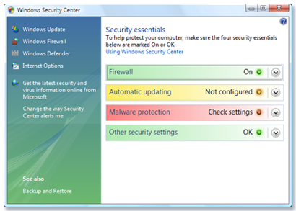

* 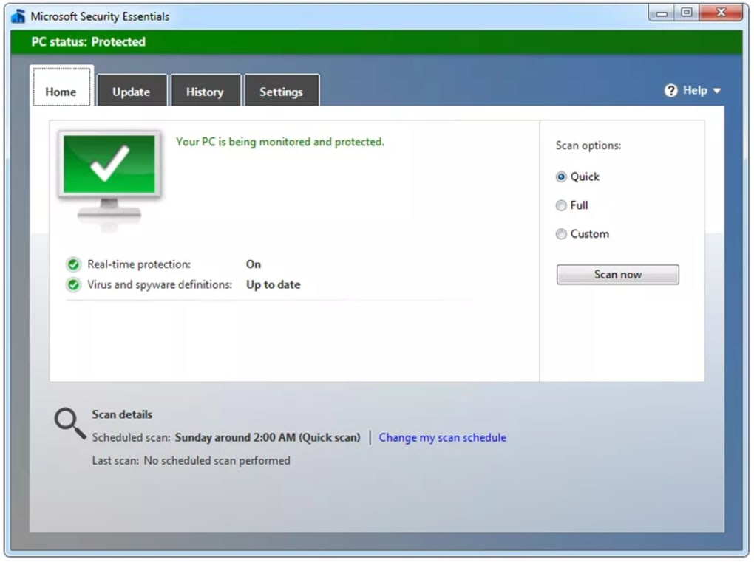

**Topic F – File System & User Accounts**

Microsoft Windows employs two major file systems: NTFS, the primary format most modern versions of this OS use by default, and FAT, which was inherited from old DOS and has exFAT as its later extension. In addition, the ReFS file system was developed by Microsoft as a new generation file system for server computers starting from Windows Server 2012.

FAT: FAT (File Allocation Table) is one of the simplest file system types, which has been around since the 1980s. It consists of the file system descriptor sector (boot sector or superblock), the file system block allocation table (referred as the File Allocation Table) and plain storage space for storing files and folders. Files in FAT are stored in directories. Each directory is an array of 32-byte records, each defining a file or extended attributes of a file (e.g. a long file name). A file record attributes the first block of a file. Any next block can be found through the block allocation table by using it as a linked list. The block allocation table contains an array of block descriptors. A zero value indicates that the block is not used and a non-zero one relates to the next block of a file or a special value for the file end. The numbers in FAT12, FAT16, FAT32 stand for the number of bits used to enumerate a file system block. This means that FAT12 can use up to 4096 different block references, while FAT16 and FAT32 can use up to 65536 and 4294967296 accordingly. The actual maximum count of blocks is even less and depends on the implementation of the file system driver. FAT12 and FAT16 used to be applied to old floppy disks and do not find extensive employment nowadays. FAT32 is still widely used for memory cards and USB sticks. The system is supported by smartphones, digital cameras and other portable devices. FAT32 can be used on Windows-compatible external storages or disk partitions with the size under 32 GB (Windows cannot create a FAT32 file system which would be larger than 32 GB, although Linux supports the size up to 2 TB) and doesn't allow to create files the size of which exceeds 4GB. To address this issue, exFAT was introduced, which doesn't have any realistic limitations concerning the size of files or partitions.

NTFS: NTFS (New Technology File System) was introduced in 1993 with Windows NT and is currently the most common file system for end user computers based on Windows. Most operating systems of the Windows Server line use this format as well. The file system is quite reliable thanks to journaling and supports many features, including access control, encryption, etc. Each file in NTFS is stored as a file descriptor in the Master File Table and file content. The Master file table contains entries with all information about files: size, allocation, name, etc. The first 16 entries of the Master File Table are retained for the BitMap, which keeps record of all free and used clusters, the Log used for journaling records and the BadClus containing information about bad clusters. The first and the last sectors of the file system contain file system settings (the boot record or the superblock). This file system uses 48 and 64 bit values to reference files, thus being able to support data storages with extremely high capacity.

ReFS: ReFS (Resilient File System) is the latest development of Microsoft introduced with Windows 8 and now available for Windows 10. The file system architecture absolutely differs from other Windows file systems and is mainly organized in a form of the B+-tree. ReFS has high tolerance to failures due to new features included into the system. And, namely, Copy-on-Write (CoW): no metadata is modified without being copied; data is not written over the existing data, but into new disk space. With any file modifications, a new copy of metadata is stored into free storage space, and then the system creates a link from older metadata to the newer one. Thus, the system stores significant quantity of older backups in different places providing easy file recovery unless this storage space is overwritten.

Some graphics:

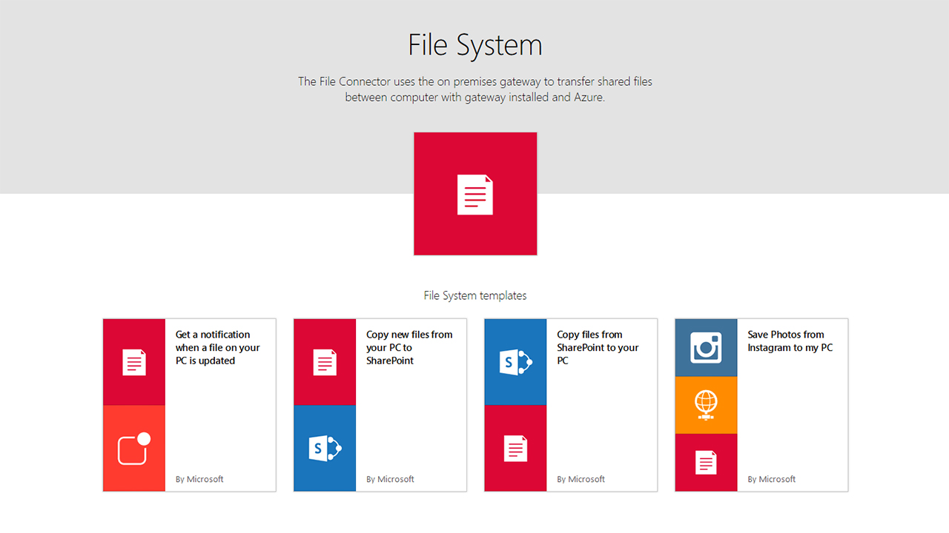

**Topic G – Special Features of your OS**

1. New Start Menu

Microsoft has brought back the Start Menu. Now, when you click on the Start button at the bottom left of the screen, you get two panels side by side, with the left column showing pinned, recently and most-used apps. You also get a power button at the top for options such as Hibernate, Standby and Shutdown, while the right column features a selection of live tiles that you can customize, resize and reorganize. Plus, you can have the Start Menu expand to full screen whenever you want, eliminating the need for a Modern UI Start Screen.

2. Cortana Integration

Windows 10 will bring Microsoft’s voice-controlled digital assistant Cortana to desktop computers, to make it easier for you to interact with your device without lifting a finger. You will be able to search your hard drive for specific files, pull up photos from specific dates, or launch PowerPoint presentations just by telling your PC to do so. You can even get Cortana to send an email while you’re working on a spreadsheet, making multi-tasking much easier.

3. Microsoft Edge Web Browser

Internet Explorer was replaced by Microsoft Edge, which features a new rendering engine called EdgeHTML. Edge also integrates with the Cortana Digital Assistant to provide voice control, search, and personalized info to users. Users can also use Edge to annotate web pages, and these annotations are stored on OneDrive and can be used with other users. There is also a “Reading List” function that syncs content between devices and a “Reading Mode” that strips out formatting to allow easier reading on devices. Many of the alterations have been made to keep Edge more in line with rival browsers, such as Chrome and Firefox.

4. Virtual Desktops

Unless you have a multi-monitor setup it can be easy to run out of screen space. For that reason, Windows 10 provides multiple desktops that you can work in and quickly switch between. The virtual desktops feature in Windows 10 is called “Task View” and is located on the Taskbar. To add a new desktop, all you need to do is click the Plus sign. You create multiple desktops, and switching between them is just a matter of clicking the Task View button again and moving your mouse over the thumbnail of the one you want. Once the workspace is displayed above, click on it (or click the Task View button again) to start using it.

5. Universal Apps

To make the transition across devices more seamless, Microsoft is introducing a new category of software called Universal Apps, which use the same code but adapt their interface to the device in your hand. Microsoft is also bundling its own set of Universal apps with the OS, including Photos, Videos, Music, Maps, People & Messaging and Mail & Calendar, which all function the same way on tablets, phones and PCs. The content is stored and synced via Microsoft’s cloud service OneDrive so you can pick up where you left off on another device.

Some Graphics:

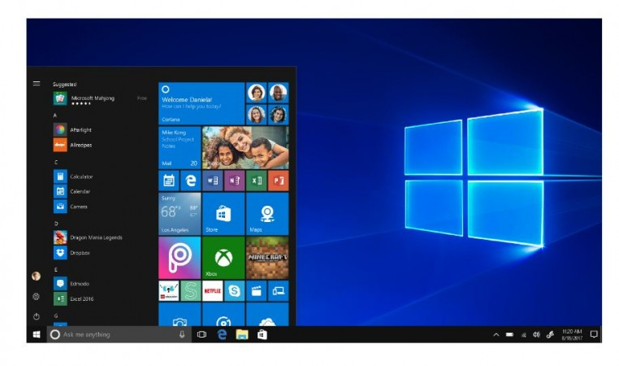

**Topic H – Limitations of your OS**

1) High resource requirements. As opposed to the makers of other operating systems, Microsoft requires its customers to invest the most in their computer hardware: a faster processor (the CPU), more internal memory and a larger hard disk. Microsoft have always maintained that this is due to all the extra functionality that they've added, as demanded by their customers. Actually, few people make use of many of those features, yet everyone is still forced to contend with the additional overhead that is the result.

2) Closed Source. Troubleshooting problems with Windows would be so much easier for users and support personnel if only they knew what was actually going on. Unfortunately, only Microsoft has full access to its software's source code, and since no log files are generated its users are left to try and deduce what causes their problems by trial and error alone. At best this is time-consuming, while at worst it can make a program impossible to work with. See also: "Shared Source".

3) Poor security. Compared to other operating systems, Microsoft security is weak. According to their own developers, their products "just aren't engineered for security." The result is that Windows computers are more likely than other systems to be hijacked and used to distribute everything from spam to hate mail. Even worse, any such activity only points to the computer that was compromised: since Windows does not generate log files, the owner has no way of proving anyone else's involvement. Another aspect of this issue has to do with internal security from an administrative point of view. Configuring any computer is time-consuming and Windows is certainly no exception. Therefore, it's better if users can be prevented from making changes to certain parts of the system, whether on purpose or by accident. Unfortunately, only with great difficulty is it possible to achieve a level of fine-grained administrative control on Windows systems, which is why it is rarely seen outside of larger organizations. What all this means for businesses is that Windows systems require a lot more time and effort to maintain than other systems. Failure to do so will only result in more lost productivity or worse.

4) Virus susceptibility. This subject is usually regarded as part Microsoft's general problems with security. However, the susceptibility of any of Microsoft's operating systems to computer viruses has always been pronounced; nearly all computer viruses target Windows computers and regularly wreak newsworthy havoc. Indeed, if it wasn't for Windows, the multi-million dollar anti-virus industry as as we know it would be virtually non-existent. Viruses on other platforms, save for perhaps the older Mac operating systems, are strictly a rarity. What this means for businesses, is that that they have no choice but to keep investing in anti-virus software for all of their Windows computers, as well as to keep up with the almost daily release of Microsoft security patches.

5) Additional expenses. After setting up a series of Microsoft computers, or even a single one for that matter, sooner or later customers invariably find themselves in need of additional software. For example, a virus scanner is mandatory nowadays, but many also believe a spyware blocker is essential as well. But, that's just the cheap stuff. If you run a Windows-based website, for instance, you may find yourself investing a lot of money in development tools, most of which are Microsoft products. The costs of applications that can run on your web site are usually higher than that of other systems. For example, you can find loads of free scripts and applications to run services such as web boards, chat rooms, web statistics and email for Linux-based web sites, but you won't find many free applications in the Microsoft world.

6) Poor stability. For people who are used to dealing with Windows, resetting and reinstalling are such a regular occurance that most don't even give it a second thought. However, that is by no means an excuse for such poor performance: Windows should not freeze up and reboot simply because Word or Internet Explorer was being used. And yes, this is because Microsoft products are full of bugs − no matter what Bill Gates says. Nevertheless, it seems most people have become largely desensitized on this issue − as if it's a natural consequence of the complexity involved. But, it doesn't have to be that way: every other major operating system available today has a better track record.

7) Backwards incompatible file formats. A well-known drawback of using Microsoft applications such as Office (Word, Excel, etc.), is that their file formats are not backwards compatible. For instance, this means that a document created in the MS Word 2002 format cannot be interpreted in any way by someone using Word 97. Microsoft has always maintained that this is because of all the new features that have been added to each new document format, but the truth is that it would have been easy for Microsoft's developers to create a common file format that would have allowed all versions of Word to simply ignore any new and unrecognised formatting features. No, they chose to do things differently because their method is the one that keeps their customers upgrading. Finally, upgrading the applications often forces you to upgrade the entire operating system as well.

8) Poor support for older hardware. Legacy support for older hardware is gone in Windows 2000 and Windows XP. Microsoft claims this was necessary to increase the overall stability of their systems, but if other systems with excellent reputations for stability include much better support for older hardware, where does this leave Microsoft's argument?

9) Poor remote access. As opposed to many of the alternatives available, MS-DOS, and thus Windows after it, were never designed with remote access in mind. That's not to say that it isn't done − it is, because it's a great way to save on administration costs − it's just that the solutions have always left something to be desired. They're unreliable, insecure (especially via the Internet), expensive, need too much bandwidth or require extra Microsoft network components to work. Invariably, it's a combination of these characteristics.

Bibliography:

Topic A:

<https://en.wikipedia.org/wiki/List_of_Microsoft_software>

Topic B:

<https://docs.microsoft.com/en-us/windows/desktop/appuistart/user-interface-technologies-for-windows-applications>

Topic C:

<https://docs.microsoft.com/en-us/windows/desktop/memory/comparing-memory-allocation-methods>

Topic D:

<https://docs.microsoft.com/en-us/windows/desktop/taskschd/task-scheduler-start-page>

Topic E:

<https://en.wikipedia.org/wiki/Windows_Update>

Topic F:

<https://www.ufsexplorer.com/articles/file-systems-basics.php>

Topic G:

<https://blog.nhlearningsolutions.com/blog/top-5-features-of-windows-10>

Topic H:

<http://www.rjsystems.nl/en/3200.php>

Level 3 – Concept Map

Create a “concept map” as a final report of your organized research.

Use the PowerPoint template provided as a starting point.

You can use PowerPoint or another concept mapping tool of your choice.

Select the best and most interesting information from your organized research.

Summarize and edit your information to fit on the concept map.

Share your finished concept map with Mr. Nestor at p0079141@pdsb.net

A concept map can be created using the “Smart Ideas” application or PowerPoint or other applications. A concept map template can be downloaded from the “Topic A” folder on the class GitHub repository